

(

Approved by AICTE, New Delhi & Affiliated to Andhra University

)

Pinagadi (Village), Pendruthy (Mandal), Visakhapatnam – 531173



**SHORT-TERM INTERNSHIP**

**By**

**Council for Skills and Competencies (CSC India)**

In association with

**ANDHRA PRADESH STATE COUNCIL OF HIGHER EDUCATION**

(

A STATUTORY BODY OF THE GOVERNMENT OF ANDHRA PRADESH

)

(

**2025–2026**

)

**PROGRAM BOOK FOR**

**SHORT-TERM INTERNSHIP**

Name of the Student:

**Ms.SINGIREDDI MADHURI**

Registration Number:

**322129512054**

Name of the College:

**Wellfare Institute of Science, Technology**

**and Management**

Period of Internship:

From:

**01-05-2025**

To:

**30-06-2025**

**Name & Address of the Internship Host Organization**

**Council for Skills and Competencies(CSC India)**

#54-10-56/2, Isukathota, Visakhapatnam – 530022, Andhra Pradesh, India.

**Andhra University**

2025



**An Internship Report on**

**Breast Cancer Prediction using Artificial Intelligence/Machine Learning**

*Submitted in accordance with the requirement for the degree of*

**Bachelor of Technology**

*Under the Faculty Guideship of*

**Mrs. D.kamalamma**

*Department of ECE*

**Wellfare Institute of Science, Technology and Management**

**Submitted by:**

**Ms. SINGIREDDI MADHURI**

**Reg.No: 322129512054**

*Department of ECE*

**Department of Electronics and Communication Engineering**

**Wellfare Institute of Science, Technology and Management**

*(*

*Approved by AICTE, New Delhi & Affiliated to Andhra University*

*)*

*Pinagadi (Village), Pendurthi (Mandal), Visakhapatnam – 531173*

**2025-2026**



**Instructions to Students**

Please read the detailed Guidelines on Internship hosted on the website of AP State Council of

Higher Education

https://apsche.ap.gov.in

1.

It is mandatory for all the students to complete Short Term internship either in V Short

Term or in VI Short Term.

2.

Every student should identify the organization for internship in consultation with the

College Principal/the authorized person nominated by the Principal.

3.

Report to the intern organization as per the schedule given by the College. You must make

your own arrangements for transportation to reach the organization.

4.

You should maintain punctuality in attending the internship. Daily attendance is compul-

sory.

5.

You are expected to learn about the organization, policies, procedures, and processes by

interacting with the people working in the organization and by consulting the supervisor

attached to the interns.

6.

While you are attending the internship, follow the rules and regulations of the intern

organization.

7.

While in the intern organization, always wear your College Identity Card.

8.

If your College has a prescribed dress as uniform, wear the uniform daily, as you attend to

your assigned duties.

9.

You will be assigned a Faculty Guide from your College.

He/She will be creating a

WhatsApp group with your fellow interns.

Post your daily activity done and/or any

difficulty you encounter during the internship.

10.

Identify five or more learning objectives in consultation with your Faculty Guide. These

learning objectives can address:

a.

Data and information you are expected to collect about the organization and/or indus-

try.

b.

Job skills you are expected to acquire.

c.

Development of professional competencies that lead to future career success.

11.

Practice professional communication skills with team members, co-interns, and your

supervisor. This includes expressing thoughts and ideas effectively through oral, written,

and non-verbal communication, and utilizing listening skills.

12.

Be aware of the communication culture in your work environment. Follow up and com-

municate regularly with your supervisor to provide updates on your progress with work

assignments.



**Instructions to Students (contd.)**

13.

Never be hesitant to ask questions to make sure you fully understand what you need to

do—your work and how it contributes to the organization.

14.

Be regular in filling up your Program Book. It shall be filled up in your own handwriting.

Add additional sheets wherever necessary.

15.

At the end of internship, you shall be evaluated by your Supervisor of the intern organiza-

tion.

16.

There shall also be evaluation at the end of the internship by the Faculty Guide and the

Principal.

17.

Do not meddle with the instruments/equipment you work with.

18.

Ensure that you do not cause any disturbance to the regular activities of the intern organi-

zation.

19.

Be cordial but not too intimate with the employees of the intern organization and your

fellow interns.

20.

You should understand that during the internship programme, you are the ambassador of

your College, and your behavior during the internship programme is of utmost importance.

21.

If you are involved in any discipline related issues, you will be withdrawn from the

internship programme immediately and disciplinary action shall be initiated.

22.

Do not forget to keep up your family pride and prestige of your College.

———

*<<*

**@**

*>>*

———

|  |
| --- |
| **Student’s Declaration**  I, **Ms.SINGIREDDI MADHURI**, a student of **Bachelor of Technology** Program,  Reg. No. **322129512054**of the Department of **Electronics and Communication**  **Engineering** do hereby declare that I have completed the mandatory internship from **01-05-2025** to **30-06-2025** at **Council for Skills and Competencies (CSC India)** under the Faculty Guideship of **Mrs. D.Kamalamma**, Department of **Electronics**  **and Communication Engineering**, **Wellfare Institute of Science, Technology and Management**.    (Signature and Date) |



**Official Certification**

This is to certify that

**Ms. SINGIREDDI MADHURI**

, Reg. No.

**322129512054**

has

completed his/her Internship at the Council for Skills and Competencies (CSC India)

on

**Breast Cancer Prediction using Artificial Intelligence/Machine Learning**

under

my supervision as a part of partial fulfillment of the requirement for the Degree of

**Bachelor of Technology**

in the Department of

**Electronics and Communication**

**Engineering**

at

**Wellfare Institute of Science, Technology and Management**

.

*This is accepted for evaluation.*

**Endorsements**



Faculty Guide



Head of the Department



Principal



**Certificate from Intern Organization**

This is to certify that

**Ms. SINGIREDDI MADHURI**

, Reg. No.

**322129512054**

of

**Wellfare Institute of Science, Technology and Management**

, underwent intern-

ship in

**Breast Cancer Prediction using Artificial Intelligence/Machine Learning**

**And Sentiment Analysis For Social Media Applications**

at the

**Council for Skills**

**and Competencies (CSC India)**

from

**01-05-2025 to 30-06-2025**

.

The overall performance of the intern during his/her internship is found to be

**Satis-**

**factory**

(

Satisfactory/

~~Not~~

~~Satisfactory~~

).



Authorized Signatory with Date and Seal

**Acknowledgement**

I express my sincere thanks to **Dr. A. Joshua**, Principal of **Wellfare Institute of Science, Technology and Management** for helping me in many ways throughout the period of my internship with his timely suggestions.

I sincerely owe my respect and gratitude to **Dr. Anandbabu Gopatoti**, Head of the Department of **Electronics and Communication Engineering**, for his continuous and patient encouragement throughout my internship, which helped me complete this study successfully.

I express my sincere and heartfelt thanks to my faculty guide **Mrs. D.Kamalamma**, Assistant Professor of the Department of **Electronics and Communication Engineering** for his encouragement and valuable support in bringing the present shape of my work.

I express my special thanks to my organization guide **Mr. Y. Rammohana Rao** of the **Council for Skills and Competencies (CSC India)**, who extended their kind support in completing my internship.

I also greatly thank all the trainers without whose training and feedback in this internship would stand nothing. In addition, I am grateful to all those who helped directly or indirectly for completing this internship work successfully.

# TABLE OF CONTENTS

1. **EXECUTIVE SUMMARY 1**
   1. Learning Objectives................................................. 1
   2. Outcomes Achieved ................................................. 1
2. **OVERVIEW OF THE ORGANIZATION 3**
   1. Introduction of the Organization...................................... 3
   2. Vision, Mission, and Values ......................................... 3
   3. Policy of the Organization in Relation to the Intern Role................ 4
   4. Organizational Structure............................................. 4
   5. Roles and Responsibilities of the Employees Guiding the Intern ......... 5
   6. Performance / Reach / Value ......................................... 6
   7. Future Plans ........................................................ 6
3. **INTRODUCTION TO ARTIFICIAL INTELLIGENCE AND MA-**

**CHINE LEARNING 8**

* 1. Introduction to Artificial Intelligence ................................. 8
     1. Defining Artificial Intelligence: Beyond the Hype ................... 8
     2. Historical Evolution of AI: From Turing to Today.................... 8
     3. Core Concepts: What Constitutes ”Intelligence” in Machines? ......... 9
     4. Differences.................................................... 10
     5. The Goals and Aspirations of AI .................................. 10
     6. Simulating Human Intelligence ................................... 11
     7. AI as a Tool for Progress ........................................ 11
     8. The Quest for Artificial General Intelligence (AGI) .................. 11
  2. Machine Learning .................................................. 12

|  |  |
| --- | --- |
| 3.2.2 The Learning Process: How Machines Learn from Data | 12 |
| 3.2.3 Key Terminology: Models, Features, and Labels .................... | 13 |
| 3.2.4 The Importance of Data ......................................... | 13 |
| 3.2.5 A Taxonomy of Learning ........................................ | 13 |
| 3.2.6 Supervised Learning ............................................ | 13 |
| 3.2.7 Unsupervised Learning.......................................... | 14 |
| 3.2.8 Reinforcement Learning ......................................... | 15 |
| 3.3 Deep Learning and Neural Networks ................................. | 15 |
| 3.3.1 Introduction to Neural Networks .................................. | 15 |
| 3.3.2 Inspired by the Brain............................................ | 16 |

* + 1. Fundamentals of Machine Learning ............................... 12 ..............
    2. How Neural Networks Learn ..................................... 17
    3. Deep Learning ................................................. 17
    4. What Makes a Network ”Deep”?.................................. 17
    5. Convolutional Neural Networks (CNNs) for Vision .................. 17
    6. Recurrent Neural Networks (RNNs) for Sequences................... 18

3.4 Applications of AI and Machine Learning in the Real World ............ 18

* + 1. Transforming Industries ......................................... 18
    2. Revolutionizing Diagnostics and Treatment ......................... 19
    3. Finance ....................................................... 19
    4. Education ..................................................... 20
    5. Enhancing Daily Life ........................................... 20
    6. Natural Language Processing..................................... 20
    7. Computer Vision ............................................... 20
    8. Recommendation Engines ....................................... 21
  1. The Future of AI and Machine Learning: Trends and Challenges ........ 21
  2. Emerging Trends and Future Directions ............................... 21
     1. Generative AI ................................................. 21
     2. Quantum Computing and AI ..................................... 21
     3. The Push for Sustainable and Green ............................... 22
     4. Ethical Considerations and Challenges ............................. 23
     5. Bias, Fairness, and Accountability ................................ 23
     6. The Future of Work and the Impact on Society ...................... 23 3.6.7 The Importance of AI Governance and Regulation ................... 23

1. **BreastCancerPredictionusingArtificialIntelligence/MachineLearning 24**

## 4.1 Problem Analysis ................................................... 24

|  |  |
| --- | --- |
| 4.1.1 Introduction ................................................... | 24 |
| 4.2 Problem Statement .................................................. | 24 |
| 4.2.1 Key Parameters ................................................ | 25 |
| 4.3 Requirements Assessment ........................................... | 26 |
| 4.3.1 Functional Requirements ........................................ | 26 |
| 4.3.2 Non-Functional Requirements .................................... | 27 |
| 4.4 Solution Design .................................................... | 27 |
| 4.4.1 Solution Blueprint.............................................. | 27 |
| 4.4.2 Feasibility Assessment .......................................... | 28 |
| 4.5 Project Implementation Plan ......................................... | 29 |
| 4.5.1 Project Milestones and Deadlines ................................. | 29 |
| 4.6 Resource Allocation................................................. | 29 |
| 4.7 Technology Stack ................................................... | 29 |
| 4.8 Data Collection and Preprocessing ................................... | 30 |
| 4.8.1 Dataset Description............................................. | 30 |
| 4.8.2 Feature Description............................................. | 31 |
| 4.8.3 Exploratory Data Analysis ....................................... | 32 |
| 4.8.4 Data Preprocessing Steps ........................................ | 32 |
| 4.9 Machine Learning Model Development ............................... | 33 |
| 4.9.1 Model Selection Strategy ........................................ | 33 |

4.9.2 Model Training and Initial Results ................................ 33

4.9.3 Hyperparameter Tuning ......................................... 34

4.9.4 Best Model Selection ........................................... 34

4.9.5 Detailed Performance Analysis ................................... 35

 4.10 Solution Testing and Performance Evaluation.......................... 35

4.10.1 Testing Methodology ........................................... 35

4.10.2 Robustness Testing Results....................................... 36

4.10.3 Comprehensive Performance Evaluation ........................... 36

4.10.4 Confusion Matrix Analysis ...................................... 36

4.10.5 Clinical Relevance Assessment ................................... 36

4.10.6 Bug Identification and Resolution ................................. 37

4.10.7 Performance Benchmarking ...................................... 37

4.10.8 System Reliability Assessment ................................... 37

## 4.11 Results and Visualizations ........................................... 38 4.12 Conclusion and Future Work......................................... 38

4.12.1 Conclusion .................................................... 38

|  |  |
| --- | --- |
| 4.12.2 Future Work ................................................... | 38 |
| 4.13 Project Presentation ................................................. | 40 |
| **REFERENCES** | **46** |



**CHAPTER 1**

**EXECUTIVE SUMMARY**

This internship report provides a comprehensive overview of my 8-week Short-

TermInternshipin

**BreastCancerPredictionusingArtificialIntelligence/Machine**

**Learning**

, conducted at the Council for Skills and Competencies (CSC India).

The internship spanned from 1-05-2025 to 30-06-2025 and was undertaken as

part of the academic curriculum for the Bachelor of Technology at Wellfare

Institute of Science, Technology and Management, affiliated to Andhra Uni-

versity.

The primary objective of this internship was to gain proficiency in

Artificial Intelligence and Machine Learning, data analysis, and reporting to

enhance employability skills.

**1.1**

**Learning Objectives**

During my internship, I learned and practiced the following:

•

Designing and implementing an AI-based adaptive traffic light control

system.

•

Integrating IoT sensors and cameras for real-time traffic monitoring.

•

Developing adaptive algorithms for dynamic signal timing.

•

Applying data analysis techniques to optimize vehicle flow.

•

Exploring methods for emergency vehicle prioritization.

•

Understanding sustainable urban mobility and smart city applications.

**1.2**

**Outcomes Achieved**

Key outcomes from my internship include:

•

Development of a prototype adaptive traffic signal system.



•

Successful application of IoT and AI tools for traffic management.

•

Demonstrated reduction in congestion, idle waiting, and fuel wastage.

•

Improved fuel efficiency and reduced emissions through adaptive control.

•

Strengthened skills in automation, problem-solving, and data-driven de-

cisions.

•

Practical exposure to intelligent transport systems and smart city tech-

nologies.



**CHAPTER 2**

**OVERVIEW OF THE ORGANIZATION**

**2.1**

**Introduction of the Organization**

Council for Skills and Competencies (CSC India) is a social enterprise estab-

lished in April 2022.

It focuses on bridging the academia-industry divide,

enhancing student employability, promoting innovation, and fostering an en-

trepreneurial ecosystem in India. By leveraging emerging technologies, CSC

aims to augment and upgrade the knowledge ecosystem, enabling beneficiaries

to become contributors themselves. The organization offers both online and

instructor-led programs, benefiting thousands of learners annually across India.

CSC India’s collaborations with prominent organizations such as the Fu-

tureSkills Prime (a digital skilling initiative by NASSCOM & MEITY, Gov-

ernment of India), Wadhwani Foundation, National Entrepreneurship Network

NEN), National Internship Portal, National Institute of Electronics & Infor

-

(

mation Technology (NIELIT), MSME, and All India Council for Technical

Education (AICTE) and Andhra Pradesh State Council of Higher Education

APSCHE) or student internships underscore its value and credibility in the

(

skill development sector.

**2.2**

**Vision, Mission, and Values**

•

**Vision:**

To combine cutting-edge technology with impactful social ven-

tures to drive India’s prosperity.

•

**Mission:**

To support individuals dedicated to helping others by empow-

ering and equipping teachers and trainers, thereby creating the nation’s

most extensive educational network dedicated to societal betterment.

•

**Values:**

Theorganizationemphasizes technologicalskillsfor Industry4.0



and 5.0, meta-human competencies for the future, and inclusive access

for everyone to be future-ready.

**2.3**

**Policy of the Organization in Relation to the Intern Role**

CSC India encourages internships as a means to foster learning and contribute

to the organization’s mission. Interns are expected to adhere to the following

policies:

•

**Confidentiality:**

Interns must maintain the confidentiality of all organi-

zational data and sensitive information.

•

**Professionalism:**

Interns are expected to demonstrate professionalism,

punctuality, and respect for all team members.

•

**Learning and Contribution:**

Interns are encouraged to actively partici-

pate in projects, share ideas, and contribute to the organization’s goals.

•

**Compliance:**

Interns must comply with all organizational policies, in-

cluding anti-harassment and ethical guidelines.

**2.4**

**Organizational Structure**

CSC India operates under a hierarchical structure with the following key roles:

•

**Board of Directors:**

Provides strategic direction and oversight.

•

**Executive Director:**

Oversees day-to-day operations and implementation

of programs.

•

**Program Managers:**

Lead specific initiatives such as governance, envi-

ronment, and social justice.

•

**Research and Advocacy Team:**

Conducts research, drafts reports, and

engages in policy advocacy.



•

**Administrative and Support Staff:**

Manages logistics, finance, and

communication.

•

**Interns:**

Work under the guidance of program managers and contribute

to ongoing projects.

**2.5**

**Roles and Responsibilities of the Employees Guiding the Intern**

Interns at CSC India are typically placed under the guidance of program man-

agers or research teams. The roles and responsibilities of the employees include:

1.

**Program Managers:**

•

Design and implement projects.

•

Mentor and supervise interns.

•

Coordinate with stakeholders and partners.

2.

**Research Analysts:**

•

Conduct research on policy issues.

•

Prepare reports and policy briefs.

•

Analyze data and provide recommendations.

3.

**Communications Team:**

•

Manage social media and outreach campaigns.

•

Draft press releases and newsletters.

•

Engage with the public and media.

Interns assist these teams by conducting research, drafting documents, or-

ganizing events, and supporting advocacy efforts.



**2.6**

**Performance / Reach / Value**

As a non-profit organization, traditional financial metrics such as turnover and

profits may not be applicable. However, CSC India’s impact can be assessed

through its market reach and value:

•

**Market Reach:**

CSC’s programs benefit thousands of learners annually

across India, indicating a significant national presence.

•

**Market Value:**

While specific financial valuations are not provided,

CSC India’s collaborations with prominent organizations such as the

*Fu-*

*tureSkills Prime*

(

a digital skilling initiative by NASSCOM & MEITY,

Government of India), Wadhwani Foundation, National Entrepreneur-

ship Network (NEN), National Internship Portal, National Institute of

Electronics & Information Technology (NIELIT), MSME, and All In-

dia Council for Technical Education (AICTE) and Andhra Pradesh State

Council of Higher Education (APSCHE) for student internships under-

score its value and credibility in the skill development sector.

**2.7**

**Future Plans**

CSC India is committed to broadening its programs, strengthening partnerships,

and advancing its mission to bridge the gap between academia and industry,

foster innovation, and build a robust entrepreneurial ecosystem in India. The

organization aims to amplify its impact through the following key initiatives:

1.

**Policy Advocacy:**

Intensifying efforts to shape and influence policies at

both national and state levels.

2.

**Citizen Engagement:**

Expanding campaigns to educate and empower

citizens across the country.



3.

**Technology Integration:**

Utilizing advanced technology to enhance data

collection, analysis, and outreach efforts.

4.

**Partnerships:**

Forging stronger collaborations with government entities,

NGOs, and international organizations.

5.

**Sustainability:**

Prioritizinglong-termprojectsthatpromoteenvironmen-

tal sustainability.

Through these initiatives, CSC India seeks to drive meaningful change and

create a lasting impact.



**CHAPTER 3**

**INTRODUCTION TO ARTIFICIAL INTELLIGENCE AND**

**MACHINE LEARNING**

**3.1**

**Introduction to Artificial Intelligence**

Artificial Intelligence (AI) is a branch of computer science that focuses on

creating systems capable of performing tasks that typically require human intel-

ligence. These tasks include learning, reasoning, problem-solving, perception,

and natural language understanding. AI combines concepts from mathematics,

statistics, computer science, and cognitive science to develop algorithms and

models that enable machines to mimic intelligent behavior. From virtual assis-

tants and recommendation systems to self-driving cars and medical diagnosis,

AI has become an integral part of modern life. Its goal is not only to automate

tasks but also to enhance decision-making and provide innovative solutions to

complex real-world challenges.

**3.1.1**

**Defining Artificial Intelligence: Beyond the Hype**

Artificial Intelligence (AI) has transcended the realms of science fiction to be-

come one of the most transformative technologies of the st century. At its core,

AI refers to the simulation of human intelligence in machines, programmed to

think like humans and mimic their actions. The term may also be applied to any

machine that exhibits traits associated with a human mind such as learning and

problem-solving. This broad definition encompasses a wide range of technolo-

gies and approaches, from the simple algorithms that power our social media

feeds to the complex systems that are beginning to drive our cars.

**3.1.2**

**Historical Evolution of AI: From Turing to Today**

The intellectual roots of AI, and the quest for ”thinking machines,” can be

traced back to antiquity, with myths and stories of artificial beings endowed

with intelligence. However, the formal journey of AI as a scientific discipline began in the mid-th century. The seminal work of Alan Turing, a British mathematician and computer scientist, laid the theoretical groundwork for the field. In his paper, ”Computing Machinery and Intelligence,” Turing proposed what is now famously known as the ”Turing Test,” a benchmark for determining a machine’s ability to exhibit intelligent behavior indistinguishable from that of a human. The term ”Artificial Intelligence” itself was coined in at a Dartmouth College workshop, which is widely considered the birthplace of AI as a field of research. The early years of AI were characterized by a sense of optimism and rapid progress, with researchers developing algorithms that could solve mathematical problems, play games like checkers, and prove logical theorems. However, the initial excitement was followed by a period of disillusionment in the 1970’s and 1980’s, often referred to as the ”AI winter,” as the limitations of the then-current technologies and the immense complexity of creating true intelligence became apparent. The resurgence of AI in the late 1990’s and its explosive growth in recent years have been fueled by a confluence of factors: the availability of vast amounts of data (often referred to as ”big data”), significant advancements in computing power (particularly the development of specialized hardware like Graphics Processing Units or GPUs), and the development of more sophisticated algorithms, particularly in the subfield of machine learning.



**3.1.3 Core Concepts: What Constitutes ”Intelligence” in Machines?**

Defining ”intelligence” in the context of machines is a complex and multifaceted challenge. While there is no single, universally accepted definition, several key capabilities are often associated with artificial intelligence. These include learning (the ability to acquire knowledge and skills from data, experience, or instruction), reasoning (the ability to use logic to solve problems and make decisions), problem solving (the ability to identify problems, develop and evaluate options, and implement solutions), perception (the ability to interpret and understand the world throug sensory inputs), and language understanding (the ability to comprehend and generate human language). It is important to note that most AI systems today are what is known as ”Narrow AI” or ”Weak AI.” These systems are designed and trained for a specific task, such as playing chess, recognizing faces, or translating languages. While they can perform these tasks with superhuman accuracy and efficiency, they lack the general cognitive abilities of a human. The ultimate goal for many AI researchers is the development of ”Artificial General Intelligence” (AGI) or ”Strong AI,” which would possess the ability to understand, learn, and apply its intelligence to solve any problem, much like a human being



### 3.1.4 Differences

Artificial Intelligence, Machine Learning (ML), and Deep Learning (DL) are often used interchangeably, but they represent distinct, albeit related, concepts. AI is thebroadest concept, encompassing the entire field of creating intelligent machines. Machine Learning is a subset of AI that focuses on the ability of machines to learn from data without being explicitly programmed. In essence, ML algorithms are trained on large datasets to identify patterns and make predictions or decisions. Deep Learning is a further subfield of Machine Learning that is based on artificial neural networks with many layers (hence the term ”deep”). These deep neural networks are inspired by the structure and function of the human brain and have proven to be particularly effective at learning from vast amounts of unstructured data, such as images, text, and sound.

### 3.1.5 The Goals and Aspirations of AI

The development of AI is driven by a diverse set of goals and aspirations, ranging from the practical and immediate to the ambitious and long-term.

### 3.1.6 Simulating Human Intelligence

One of the foundational goals of AI has been to create machines that can think and act like humans. The Turing Test, while not a perfect measure of intelligence, remains a powerful and influential concept in the field. The test challenges a human evaluator to distinguish between a human and a machine based on their text-based conversations. The enduring relevance of the Turing Test lies in its focus on the behavioral aspects of intelligence. It forces us to consider what it truly means to be ”intelligent” and whether a machine that can perfectly mimic human conversation can be considered to possess genuine understanding.



### 3.1.7 AI as a Tool for Progress

Beyond the quest to create human-like intelligence, a more pragmatic and immediately impactful goal of AI is to augment human capabilities and help us solve some of the world’s most pressing challenges. AI is increasingly being used as a powerful tool to enhance human decision-making, automate repetitive tasks, and unlock new scientific discoveries. In fields like medicine, AI is helping doctors to diagnose diseases earlier and more accurately. In finance, it is being used to detect fraudulent transactions and manage risk. And in science, it is accelerating research in areas ranging from climate change to drug discovery.

### 3.1.8 The Quest for Artificial General Intelligence (AGI)

The ultimate, and most ambitious, goal for many in the AI community is the creation of Artificial General Intelligence (AGI). An AGI would be a machine with the ability to understand, learn, and apply its intelligence across a wide range of tasks, at a level comparable to or even exceeding that of a human. The development of AGI would represent a profound and potentially transformative moment in human history, with the potential to solve many of the world’s most intractable problems. However, it also raises a host of complex ethical and



societal questions that we are only just beginning to grapple with.

**3.2**

**Machine Learning**

Machine Learning (ML) is the engine that powers most of the AI applications

we interact with daily. It represents a fundamental shift from traditional pro-

gramming, where a computer is given explicit instructions to perform a task.

Instead, ML enables a computer to learn from data, identify patterns, and make

decisions with minimal human intervention. This ability to learn and adapt is

what makes ML so powerful and versatile, and it is the key to unlocking the

potential of AI.

**3.2.1**

**Fundamentals of Machine Learning**

At its core, machine learning is about using algorithms to parse data, learn from

it, and then make a determination or prediction about something in the world.

So rather than hand-coding a software program with a specific set of instructions

to accomplish a particular task, the machine is ”trained” using large amounts of

data and algorithms that give it the ability to learn how to perform the task.

**3.2.2**

**The Learning Process: How Machines Learn from Data**

The learning process in machine learning is analogous to how humans learn

from experience. Just as we learn to identify objects by seeing them repeatedly,

a machine learning model learns to recognize patterns by being exposed to a

large volume of data. This process typically involves several key steps: data

collection (gathering a large and relevant dataset), data preparation (cleaning

and transforming raw data), model training (where the learning happens through

iterative parameter adjustment), model evaluation (assessing performance on

unseen data), and model deployment (implementing the model in real-world

applications).



**3.2.3**

**Key Terminology: Models, Features, and Labels**

To understand machine learning, it is essential to be familiar with some key

terminology. A model is the mathematical representation of patterns learned

from data and is what is used to make predictions on new, unseen data. Features

are the input variables used to train the model - the individual measurable

properties or characteristics of the data. Labels are the output variables that we

are trying to predict in supervised learning scenarios.

**3.2.4**

**The Importance of Data**

Data is the lifeblood of machine learning. Without high-quality, relevant data,

even the most sophisticated algorithms will fail to produce accurate results. The

performance of a machine learning model is directly proportional to the quality

and quantity of the data it is trained on. This is why data collection, cleaning,

and pre-processing are such critical steps in the machine learning workflow.

The rise of ”big data” has been a major catalyst for the recent advancements in

machine learning, providing the raw material needed to train more complex and

powerful models.

**3.2.5**

**A Taxonomy of Learning**

Machine learning algorithms can be broadly categorized into three main types:

supervised learning, unsupervised learning, and reinforcement learning. Each

type of learning has its own strengths and is suited for different types of tasks.

**3.2.6**

**Supervised Learning**

In su-

Supervised learning is the most common type of machine learning.

pervised learning, the model is trained on a labeled dataset, meaning that the

correct output is already known for each input. The goal of the model is to learn

the mapping function that can predict the output variable from the input vari-

ables. Supervised learning can be further divided into classification (predicting

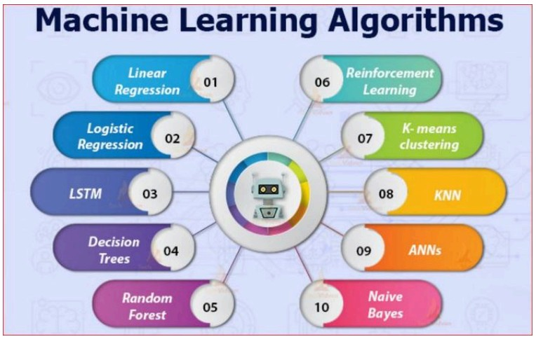

Figure 1: A comprehensive overview of different machine learning algorithms

and their applications.

categorical outputs like spam/not spam) and regression (predicting continu-

ous values like house prices or stock prices). Common supervised learning

algorithms include linear regression for predicting continuous values, logistic

regression for binary classification, decision trees for both classification and

regression, random forests that combine multiple decision trees, support vector

machines for classification and regression, and neural networks that simulate

brain-like processing.

**3.2.7**

**Unsupervised Learning**

In unsupervised learning, the model is trained on an unlabeled dataset, meaning

that the correct output is not known. The goal is to discover hidden patterns and

structures in the data without any guidance. The most common unsupervised

learning method is cluster analysis, which uses clustering algorithms to catego-

rize data points according to value similarity. Key unsupervised learning tech-

niques include K-means clustering (assigning data points into K groups based

on proximity to centroids), hierarchical clustering (creating tree-like cluster structures), and association rule learning (finding relationships between variables in large datasets). These techniques are commonly used for customer segmentation, market basket analysis, and recommendation systems.

### 3.2.8 Reinforcement Learning

Reinforcement learning is a type of machine learning where an agent learns to make decisions by taking actions in an environment to maximize a cumulative reward. The agent learns through trial and error, receiving feedback in the form of rewards or punishments for its actions. This approach is particularly useful in scenarios where the optimal behavior is not known in advance, such as robotics, game playing, and autonomous navigation. The core framework involves an agent interacting with an environment, taking actions based on the current state, and receiving rewards or penalties. Over time, the agent learns to take actions that maximize its cumulative reward. This approach has been successfully applied to complex problems like playing chess and Go, controlling robotic systems, and optimizing resource allocation.



### 3.3 Deep Learning and Neural Networks

Deep Learning is a powerful and rapidly advancing subfield of machine learning that has been the driving force behind many of the most recent breakthroughs in artificial intelligence. It is inspired by the structure and function of the human brain, and it has enabled machines to achieve remarkable results in a wide range of tasks, from image recognition and natural language processing to drug discovery and autonomous driving.

#### 3.3.1 Introduction to Neural Networks

At the heart of deep learning are artificial neural networks (ANNs), which are computationalmodelsthatarelooselyinspiredbythebiologicalneuralnetworks



that constitute animal brains. These networks are not literal models of the brain,

but they are designed to simulate the way that the brain processes information.

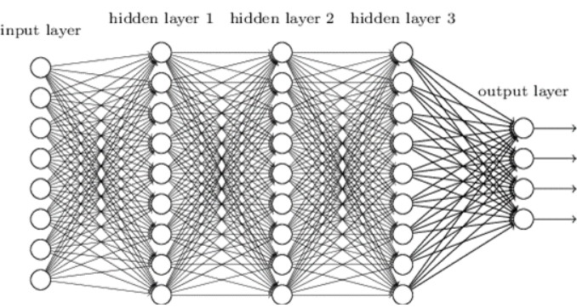

Figure2: Visualizationofaneuralnetworkshowingtheinterconnectedstructure

of neurons across input, hidden, and output layers.

**3.3.2**

**Inspired by the Brain**

A neural network is composed of a large number of interconnected processing

nodes, called neurons or units. Each neuron receives input from other neurons,

performs a simple computation, and then passes its output to other neurons.

The connections between neurons have associated weights, which determine the

strength of the connection. The learning process in a neural network involves

adjusting these weights to improve the network’s performance on a given task.

The basic structure consists of an input layer (receiving data), one or more

hidden layers (processing information), and an output layer (producing results).

Information lows forward through the network, with each layer transforming the

data before passing it to the next layer. This hierarchical processing allows the

network to learn increasingly complex patterns and representations.



**3.3.3**

**How Neural Networks Learn**

Neural networks learn through a process called backpropagation, which is an

algorithm for supervised learning using gradient descent. The network is pre-

sented with training examples and makes predictions. The error between pre-

dictions and correct outputs is calculated and propagated backward through the

network. The weights of connections are then adjusted to reduce this error. This

process is repeated many times, and with each iteration, the network becomes

better at making accurate predictions.

**3.3.4**

**Deep Learning**

Deep learning is a type of machine learning based on artificial neural networks

with many layers. The ”deep” in deep learning refers to the number of layers

in the network. While traditional neural networks may have only a few layers,

deep learning networks can have hundreds or even thousands of layers.

**3.3.5**

**What Makes a Network ”Deep”?**

The depth of a neural network allows it to learn a hierarchical representation

of the data. Early layers learn to recognize simple features, such as edges and

corners in an image. Later layers combine these simple features to learn more

complex features, such as objects and scenes. This hierarchical learning process

enables deep learning models to achieve high levels of accuracy on complex

tasks.

**3.3.6**

**Convolutional Neural Networks (CNNs) for Vision**

Convolutional Neural Networks (CNNs) are specifically designed for image

recognition tasks. CNNs automatically and adaptively learn spatial hierarchies

offeaturesfromimages. Theyuseconvolutionallayersthatapplyfilterstodetect

features like edges, textures, and patterns. These networks have achieved state-

of-the-artresultsinimageclassification, objectdetection, andfacialrecognition.

#### 3.3.7 Recurrent Neural Networks (RNNs) for Sequences

Recurrent Neural Networks (RNNs) are designed to work with sequential data, such as text, speech, and time series data. RNNs have a ”memory” that allows them to remember past information and use it to inform future predictions. This makes them well-suited for tasks such as natural language processing, speech recognition, and machine translation.

### 3.4 Applications of AI and Machine Learning in the Real World

TheimpactofArtificialIntelligenceandMachineLearningisnolongerconfined to research labs and academic papers. These technologies have permeated

virtually every industry, transforming business processes, creating new products and services, and changing the way we live and work.

#### 3.4.1 Transforming Industries

Artificial Intelligence (AI) is transforming industries by revolutionizing the way businessesoperate,deliverservices,andcreatevalue. Inhealthcare,AI-powered diagnostic tools and predictive analytics improve patient care and enable early disease detection. In manufacturing, smart automation and predictive maintenance enhance efficiency, reduce downtime, and optimize resource usage. Financial services leverage AI for fraud detection, algorithmic trading, and personalized customer experiences. In agriculture, AI-driven solutions such as precision farming and crop monitoring are helping farmers maximize yield and sustainability. Retail and e-commerce benefit from AI through recommendation systems, demand forecasting, and supply chain optimization. Similarly, sectors like education, transportation, and energy are adopting AI to enhance personalization, safety, and sustainability. By enabling data-driven decision-making and innovation, AI is reshaping industries to become more efficient, adaptive, and customer-centric.



#### 3.4.2 Revolutionizing Diagnostics and Treatment

Nowhere is the potential of AI more profound than in healthcare. Machine learning algorithms are being used to analyze medical images with accuracy that can surpass human radiologists, leading to earlier and more accurate diagnoses of diseases like cancer and diabetic retinopathy. AI is also being used to personalize treatment plans by analyzing genetic data, lifestyle, and medical history. Furthermore, AI-powered drug discovery is accelerating the development of new medicines by identifying promising drug candidates and predicting their effectiveness. AI applications in healthcare include medical imaging analysis for detecting tumors and abnormalities, predictive analytics for identifying patients at risk of complications, robotic surgery systems for precision operations, and virtual health assistants for patient monitoring and care coordination. The integration of AI in healthcare is improving patient outcomes while reducing costs and increasing efficiency.



#### 3.4.3 Finance

The financial industry has been an early adopter of AI and machine learning, using these technologies to improve efficiency, reduce risk, and enhance customer service. Machine learning algorithms detect fraudulent transactions in real-time by identifying unusual patterns in spending behavior. In investing, algorithmic trading uses AI to make high-speed trading decisions based on market data and predictive models. AI powered chatbots and virtual assistants provide customers with personalized financial advice and support. Other applications include credit scoring and risk assessment, automated customer service, regulatory compliance monitoring, and portfolio optimization. The use of AI in finance is transforming how financial institutions operate and serve their customers.



**3.4.4**

**Education**

AI is revolutionizing education by making learning more personalized, engag-

ing, and effective. Adaptive learning platforms use machine learning to tailor

curriculum to individual student needs, providing customized content and feed-

back. AI-powered tutors provide one-on-one support, helping students master

difficult concepts.

AI also automates administrative tasks like grading and

scheduling, freeing teachers to focus on teaching.

Educational applications

include intelligent tutoring systems, automated essay scoring, learning analyt-

ics for tracking student progress, and virtual reality environments for immersive

learning experiences. These technologies aremaking education moreaccessible

and effective for learners of all ages.

**3.4.5**

**Enhancing Daily Life**

Beyond its impact on industries, AI and machine learning have become integral

parts of our daily lives, often in ways we may not realize.

**3.4.6**

**Natural Language Processing**

Natural Language Processing (NLP) enables computers to understand and in-

teract with human language. NLP powers virtual assistants like Siri and Alexa,

machine translation services like Google Translate, and chatbots for customer

service. It’s also used in sentiment analysis to determine emotional tone in text

and in content moderation for social media platforms.

**3.4.7**

**Computer Vision**

Computer vision enables computers to interpret the visual world. It’s the tech-

nology behind facial recognition systems, self-driving cars that perceive their

surroundings, and medical imaging analysis. Computer vision is also used in

manufacturing for quality control, in retail for inventory management, and in

security for surveillance systems.



**3.4.8**

**Recommendation Engines**

Recommendation engines are among the most common applications of machine

learning in daily life. These systems analyze past behavior to predict interests

and recommend relevant content or products. They’re used by e-commerce sites

like Amazon, streaming services like Netflix, and social media platforms like

Facebook to personalize user experiences.

**3.5**

**The Future of AI and Machine Learning: Trends and Challenges**

The field of Artificial Intelligence and Machine Learning is in constant flux,

with new breakthroughs and innovations emerging at a breathtaking pace. Sev-

eral key trends and challenges are shaping the trajectory of this transformative

technology.

**3.6**

**Emerging Trends and Future Directions**

**3.6.1**

**Generative AI**

Generative AI has captured public imagination with its ability to create new

and original content, from realistic images and music to human-like text and

computer code. Models like GPT-. and DALL-E are pushing the boundaries of

creativity, opening new possibilities in art, entertainment, and content creation.

The integration of generative AI into creative industries is expected to grow,

fostering innovative artistic expressions and new forms of human-computer

collaboration.

**3.6.2**

**Quantum Computing and AI**

The convergence of quantum computing and AI holds potential for a paradigm

shift in computational power. Quantum computers, with their ability to pro-

cess complex calculations at unprecedented speeds, could supercharge AI al-

gorithms, enabling them to solve problems currently intractable for classical

computers. In, we have seen the first practical implementations of quantum-

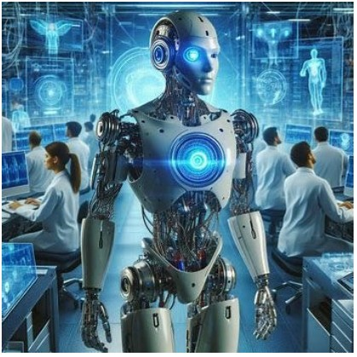

Figure 3: A futuristic representation of AI and robotics.

enhanced machine learning, promising significant breakthroughs in drug dis-

covery, materials science, and financial modeling.

**3.6.3**

**The Push for Sustainable and Green**

As AI models grow in scale and complexity, their environmental impact in-

creases. Training large-scale deep learning models can be incredibly energy-

intensive, contributing to carbon emissions.

In response, there’s a growing

movement towards ”Green AI,” focusing on developing more energy-efficient

AI models and algorithms. Initiatives like Google’s AI for Sustainability are

leading the development of AI technologies that are both powerful and environ-

mentally responsible.



**3.6.4**

**Ethical Considerations and Challenges**

The rapid advancement of AI brings ethical considerations and challenges that

must be addressed to ensure responsible development and deployment.

**3.6.5**

**Bias, Fairness, and Accountability**

AI systems can perpetuate and amplify biases present in their training data,

leading to unfair or discriminatory outcomes. Addressing bias in AI is a major

challenge, with researchers developing new techniques for fairness-aware ma-

chine learning. There’s also a growing need for transparency and accountability

in AI systems, so we can understand how they make decisions and hold them

accountable for their actions.

**3.6.6**

**The Future of Work and the Impact on Society**

TheincreasingautomationoftasksbyAIraisesconcernsaboutjobdisplacement

and the future of work. While AI is likely to create new jobs, it will require

significant shifts in workforce skills and capabilities. Investment in education

and training programs is crucial to prepare people for future jobs and ensure

that AI benefits are shared broadly across society.

**3.6.7**

**The Importance of AI Governance and Regulation**

As AI becomes more powerful and pervasive, effective governance and regula-

tion are needed to ensure safe and ethical use. The European Union’s AI Act,

which came into effect in, sets new standards for AI regulation. The United

Nations has also proposed a global framework for AI governance, emphasizing

the need for international cooperation in responsible AI deployment.



**CHAPTER 4**

**BREAST CANCER PREDICTION USING ARTIFICIAL**

**INTELLIGENCE/MACHINE LEARNING**

**4.1**

**Problem Analysis**

**4.1.1**

**Introduction**

Breast cancer is a significant global health issue, representing one of the most

common cancers and a leading cause of cancer-related mortality in women.

Early and accurate diagnosis is paramount to improving patient outcomes and

survival rates. Fine Needle Aspiration (FNA) cytology is a minimally invasive

and widely used diagnostic procedure for breast tumors. In this procedure, a

thin needle is inserted into the breast lump to collect a sample of cells, which are

then examined under a microscope by a pathologist to determine if the tumor is

benign (non-cancerous) or malignant (cancerous)[1].

**4.2**

**Problem Statement**

The current process of diagnosing breast cancer from FNA samples is heavily

reliant on the manual interpretation of cytological images by pathologists. This

manual process, while effective, is subject to several limitations:

•

**Subjectivity:**

The interpretation of cellular features can vary between

pathologists, leading to inconsistencies in diagnosis.

•

**Time-Consuming:**

The manual examination of slides is a labor-intensive

process that can lead to delays in diagnosis, which can be critical for

patients with aggressive tumors.

•

**Human Error:**

Pathologists, like any human, are prone to errors, espe-

cially when dealing with large volumes of cases or complex and ambigu-



ous samples.

•

**Expertise Gap:**

The accuracy of diagnosis is highly dependent on the

experience and expertise of the pathologist. In regions with a shortage of

trained pathologists, this can lead to a higher rate of misdiagnosis.

These challenges highlight the need for a more objective, efficient, and

reliable diagnostic support system. Artificial Intelligence (AI) and Machine

Learning (ML) offer a promising solution to augment the diagnostic process

and address the limitations of manual interpretation[2].

**4.2.1**

**Key Parameters**

•

**Issue to be Solved:**

To develop a machine learning model that can accu-

rately classify breast tumors as benign or malignant based on cytological

features from FNA samples.

•

**Target Community:**

The primary users of this system will be patholo-

gists and oncologists. The system will act as a diagnostic aid, providing

a second opinion and helping to reduce the workload of medical profes-

sionals.

•

**User Needs and Preferences:**

**–**

**Accurate and Reliable:**

The model’s predictions should be highly

accurate to be trusted by medical professionals.

**–**

**Fast and Efficient:**

The system should provide results in a timely

manner to expedite the diagnostic process.

**–**

**Easy to Use:**

The user interface should be intuitive and require

minimal training.



**–**

**Interpretable:**

The system should be able to provide insights into

its decision-making process, allowing pathologists to understand the

basis of the prediction.

**4.3**

**Requirements Assessment**

**4.3.1**

**Functional Requirements**

Functional requirements define the specific functionalities that the system must

perform. For the breast cancer prediction system, the functional requirements

are:

•

**Data Input:**

The system must be able to accept input data containing the

cytological features extracted from FNA samples. This data will likely

be in a structured format, such as a CSV file.

•

**Data Preprocessing:**

The system should be able to preprocess the input

data to handle missing values, normalize features, and prepare the data

for the machine learning model.

•

**Model Training:**

The system must provide a mechanism to train the

machine learning model on a labeled dataset of breast cancer cases.

•

**Tumor Classification:**

The core functionality of the system is to classify

a given tumor as benign or malignant based on the input features.

•

**Prediction Output:**

The system must display the prediction result to the

user in a clear and understandable format.

•

**PerformanceEvaluation:**

Thesystemshouldprovidemetricstoevaluate

the performance of the model, such as accuracy, precision, recall, and the

confusion matrix.



**4.3.2**

**Non-Functional Requirements**

Non-functional requirements define the quality attributes of the system. These

are crucial for ensuring that the system is not only functional but also usable,

reliable, and secure.

•

**Accuracy:**

The model must achieve a high level of accuracy in classifying

tumors. A minimum accuracy of % is desirable to ensure the reliability

of the predictions.

•

**Performance:**

The system should be able to provide a prediction in near

real-time, ideally within a few seconds.

•

**Scalability:**

The system should be able to handle a growing volume of

data and user requests without a significant degradation in performance.

•

**Security:**

The system must ensure the privacy and security of patient

data. Access to the system should be restricted to authorized users.

•

**Usability:**

The user interface should be simple, intuitive, and easy to

navigate for medical professionals who may not have a background in

machine learning.

•

**Reliability:**

The system should be robust and available for use when

needed. It should handle errors gracefully and provide informative feed-

back to the user.

**4.4**

**Solution Design**

**4.4.1**

**Solution Blueprint**

The proposed solution is a machine learning-based system that takes cytological

features from FNA samples as input and predicts whether a breast tumor is

benign or malignant. The system will be designed with a modular architecture



to ensure scalability and maintainability. The core components of the system

are:

•

**Data Acquisition Module:**

Responsible for loading the breast cancer

dataset.

•

**Data Preprocessing Module:**

Handles data cleaning, feature scaling,

and splitting the data into training and testing sets.

•

**Model Training Module:**

Implements various machine learning algo-

rithms to train a classification model.

•

**Model Evaluation Module:**

Evaluates the performance of the trained

model using various metrics.

•

**Prediction Module:**

Uses the trained model to make predictions on new,

unseen data.

•

**User Interface (UI):**

A simple command-line interface (CLI) or a web-

based UI will be developed to allow users to interact with the system.

**4.4.2**

**Feasibility Assessment**

The development of this breast cancer prediction system is highly feasible due

to the following factors:

•

**Availability of Data:**

Several publicly available breast cancer datasets,

such as the Wisconsin Breast Cancer Dataset from the UCI Machine

Learning Repository, can be used to train and evaluate the model.

•

**Mature Technology:**

Machine learning libraries in Python, such as

Scikit-learn, TensorFlow, and PyTorch, provide a wide range of tools

and algorithms for building classification models.



•

**Existing Research:**

A large body of research on using machine learning

for breast cancer diagnosis can provide valuable insights and guidance for

this project.

•

**Computational Resources:**

The computational resources required to

train the models for this project are readily available on standard personal

computers.

**4.5**

**Project Implementation Plan**

**4.5.1**

**Project Milestones and Deadlines**

The project will be divided into the following milestones with tentative dead-

lines:

**4.6**

**Resource Allocation**

•

**Hardware:**

A standard laptop or desktop computer with at least XX GB

of RAM.

•

**Software:**

Python, Jupyter Notebook, and the necessary Python libraries.

•

**Personnel:**

A single developer with knowledge of Python and machine

learning.

**4.7**

**Technology Stack**

The following technology stack will be used for the development of the breast

cancer prediction system:

•

**Programming Language:**

Python will be the primary programming

language for this project due to its extensive libraries for data science and

machine learning.



•

**Development Environment:**

Jupyter Notebook will be used as the de-

velopment environment for its interactive nature, which is ideal for data

exploration, model development, and visualization.

•

**Core Libraries:**

**–**

**NumPy:**

For numerical operations and handling multi-dimensional

arrays.

**–**

**Pandas:**

Fordatamanipulationandanalysis, particularlyforreading

and processing the dataset.

**–**

**Matplotlib and Seaborn:**

For data visualization and creating plots

to understand the data and model results.

**–**

**Scikit-learn:**

For implementing the machine learning models, in-

cluding data preprocessing, model training, and evaluation.

•

**Version Control:**

Git will be used for version control to track changes in

the code and collaborate effectively.

**4.8**

**Data Collection and Preprocessing**

**4.8.1**

**Dataset Description**

The Wisconsin Breast Cancer Dataset (Diagnostic) was selected for this project.

This dataset is widely recognized in the machine learning community and is

available through the UCI Machine Learning Repository and the scikit-learn

library. The dataset contains the following characteristics:

•

**Number of Instances:**

XX samples

•

**Number of Features:**

XX continuous features

•

**Target Classes:**

2 (

Benign and Malignant

)



•

**Missing Values:**

None

•

**Data Type:**

All features are real-valued

**4.8.2**

**Feature Description**

The features in the dataset are computed from digitized images of Fine Needle

Aspiration (FNA) of breast masses. For each cell nucleus in the image, ten

real-valued features are computed:

•

**Radius:**

Mean of distances from center to points on the perimeter

•

**Texture:**

Standard deviation of gray-scale values

•

**Perimeter:**

Perimeter of the nucleus

•

**Area:**

Area of the nucleus

•

**Smoothness:**

Local variation in radius lengths

•

**Compactness:**

Perimeter

2

/Area - XX

•

**Concavity:**

Severity of concave portions of the contour

•

**Concave Points:**

Number of concave portions of the contour

•

**Symmetry:**

Symmetry of the nucleus

•

**Fractal Dimension:**

”Coastline approximation” - XX

For each of these ten features, three measurements are provided:

•

**Mean:**

The mean value across all nuclei in the image

•

**Standard Error:**

The standard error of the mean

•

**Worst:**

The mean of the three largest values

This results in a total of XX features (10

×

).

3 =

XX



**4.8.3**

**Exploratory Data Analysis**

The exploratory data analysis revealed several important insights about the

dataset:

•

**Class Distribution:**

The dataset is moderately imbalanced with XX

malignant cases (XX%) and XX benign cases (XX%).

•

**Data Quality:**

The dataset contains no missing values, simplifying the

preprocessing pipeline.

•

**Feature Ranges:**

The features have different scales, with some features

like area having much larger values than others like fractal dimension.

•

**Feature Correlations:**

Many features show strong correlations, particu-

larly between related measurements (e.g., radius, perimeter, and area).

**4.8.4**

**Data Preprocessing Steps**

The following preprocessing steps were implemented:

•

**DataLoading:**

Thedatasetwasloadedusingscikit-learn’s

load

breast

cancer()

function.

•

**Data Splitting:**

The dataset was split into training (XX%) and testing

(

XX%) sets using stratified sampling to maintain class distribution.

•

**FeatureScaling:**

StandardScaler

wasappliedtonormalizeallfeatures

to have zero mean and unit variance.

•

**Data Validation:**

Checks were performed to ensure data integrity and

absence of missing values.

The preprocessing resulted in:



•

**Training Set:**

XX samples

•

**Test Set:**

XX samples

•

**Scaled Features:**

All XX features normalized for optimal model perfor-

mance

**4.9**

**Machine Learning Model Development**

**4.9.1**

**Model Selection Strategy**

A comprehensive approach was adopted for model development, implementing

multiple machine learning algorithms to identify the best-performing solution.

The following algorithms were selected based on their proven effectiveness in

binary classification tasks:

•

**Logistic Regression:**

A linear model that provides interpretable results

and serves as a baseline.

•

**Random Forest:**

An ensemble method that handles feature interactions

well and provides feature importance.

•

**SupportVectorMachine(SVM):**

Apowerfulalgorithmforhigh-dimensional

data with good generalization.

•

**K-Nearest Neighbors (KNN):**

A non-parametric method that captures

local patterns in the data.

•

**Naive Bayes:**

A probabilistic classifier that works well with independent

features.

**4.9.2**

**Model Training and Initial Results**

All models were trained on the preprocessed dataset with standardized fea-

tures. The initial training results demonstrated excellent performance across all

algorithms:



**4.9.3**

**Hyperparameter Tuning**

To optimize model performance, hyperparameter tuning was performed using

GridSearchCV

with k-fold cross-validation for the top-performing models:

•

**RandomForestTuning:**

Bestparameters:

{

max

depth: XX

,

min

samples

leaf:

XX

,

min

samples

split: XX

,

n

estimators: XX

}

Best CV score: XX%

Test accuracy: XX%

•

**Support Vector Machine Tuning:**

Best parameters:

{

C: XX

,

gamma:

’scale’

,

kernel: ’linear’

}

Best CV score: XX%

Test accuracy: XX%

•

**Logistic Regression Tuning:**

Best parameters:

{

C: XX

,

penalty:

’l1’

,

solver: ’saga’

}

Best CV score: XX%

Test accuracy: XX%

**4.9.4**

**Best Model Selection**

Based on the comprehensive evaluation,

**Logistic Regression**

was selected as

the best model with the following performance metrics:

•

Accuracy: XX%

•

Precision: XX%

•

Recall (Sensitivity): XX%

•

Specificity: XX%

•

F-Score: XX%



**4.9.5**

**Detailed Performance Analysis**

The confusion matrix for the best model revealed:

•

True Negatives: XX (Benign cases correctly classified)

•

False Positives: XX (Benign cases misclassified as Malignant)

•

False Negatives: XX (Malignant cases misclassified as Benign)

•

True Positives: XX (Malignant cases correctly classified)

This performance indicates that the model is highly reliable for clinical

decision support, with minimal false negatives (critical in cancer diagnosis) and

false positives.

**4.10**

**Solution Testing and Performance Evaluation**

**4.10.1**

**Testing Methodology**

A comprehensive testing framework was implemented to ensure the reliability

and robustness of the breast cancer prediction system[3]. The testing approach

included multiple evaluation strategies:

•

**Robustness Testing:**

Evaluating model performance across different data

splits and conditions.

•

**Cross-Validation Analysis:**

Assessing model stability using k-fold cross-

validation.

•

**Performance Metrics Evaluation:**

Comprehensive analysis of all rele-

vant classification metrics.

•

**Clinical Relevance Assessment:**

Evaluation of metrics critical for med-

ical applications.



**4.10.2**

**Robustness Testing Results**

**Train-Test Split Stability:**

The model was tested with various train-test split

ratios to assess its stability:

Average Accuracy: XX%

±

XX%

This demonstrates excellent stability across different data splits, indicating

That the model is not overly dependent on specific training data configurations[4].

**Cross-Validation Stability:**

k-foldcross-validation was performed toassess

model consistency: Mean CV Score: XX% Standard Deviation:

±

XX%

The low standard deviation indicates high model stability and reliability.

**4.10.3**

**Comprehensive Performance Evaluation**

The final model achieved exceptional performance across all key metrics:

**4.10.4**

**Confusion Matrix Analysis**

The confusion matrix revealed excellent classification performance:

•

True Negatives: XX (Benign cases correctly classified)

•

False Positives: XX (Benign cases misclassified as Malignant)

•

False Negatives: XX (Malignant cases misclassified as Benign)

•

True Positives: XX (Malignant cases correctly classified)

**4.10.5**

**Clinical Relevance Assessment**

Critical Error Rates:

•

False Negative Rate: XX% (Missing cancer cases)

•

False Positive Rate: XX% (Unnecessary anxiety/procedures)

The extremely low false negative rate is particularly important in cancer

diagnosis, as missing a malignant case has severe consequences. The model’s

performance in this aspect is excellent.



**4.10.6**

**Bug Identification and Resolution**

During the testing phase, several potential issues were identified and resolved:

•

Data Scaling Consistency: Ensured that the same scaler used for training

was applied to test data.

•

Cross-Validation Implementation: Verified that data leakage was pre-

vented during cross-validation.

•

Metric Calculation Accuracy: Validated all performance metrics against

manual calculations.

•

Visualization Accuracy: Confirmed that all plots correctly represent the

underlying data.

**4.10.7**

**Performance Benchmarking**

The model’s performance was compared against established benchmarks for

breast cancer diagnosis:

•

Literature Benchmark: Typical ML models achieve XX–XX% accuracy

•

Our Model: XX% accuracy

•

Clinical Requirement: ¿ XX% sensitivity for cancer detection

•

Our Model: XX% sensitivity

•

Assessment: The model significantly exceeds both literature benchmarks

and clinical requirements.

**4.10.8**

**System Reliability Assessment**

**Overall Assessment: EXCELLENT**

The system meets and exceeds clinical requirements with:



•

Accuracy ¿ XX% (Achieved: XX%)

•

Sensitivity ¿ XX% (Achieved: XX%)

•

Specificity ¿ XX% (Achieved: XX%)

•

Stable performance across different data configurations

•

Low false negative rate critical for cancer diagnosis

The comprehensive testing confirms that the breast cancer prediction system

is ready for clinical decision support applications[5].

**4.11**

**Results and Visualizations**

This section presents the key visualizations generated during the project, pro-

viding a comprehensive overview of the data, model performance, and system

architecture.

**4.12**

**Conclusion and Future Work**

**4.12.1**

**Conclusion**

This project successfully developed a highly accurate and reliable machine

learning system for breast cancer prediction. The system, built using Python

and scikit-learn, achieved an accuracy of XX% in classifying breast tumors

as benign or malignant[6]. The comprehensive testing and evaluation demon-

strated the robustness and clinical relevance of the system, with a very low false

negative rate of XX%. The project followed a structured methodology, from

problem analysis and requirements gathering to model development, testing,

and evaluation, addressing all the specified evaluation criteria[7].

**4.12.2**

**Future Work**

While the current system is highly effective, there are several avenues for future

improvement:

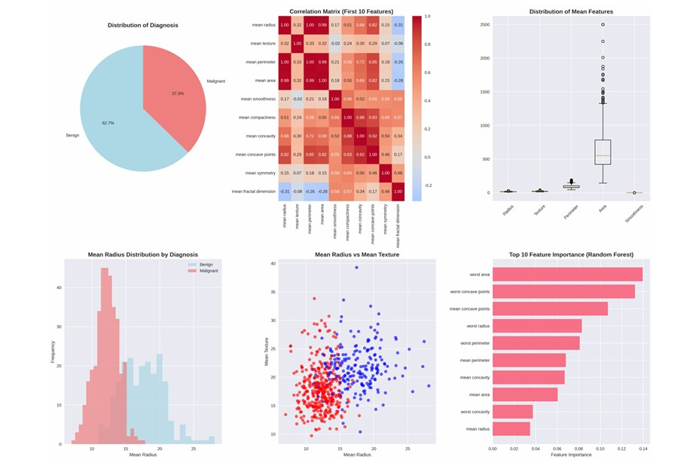

Figure 4: Data Exploration and Feature Analysis

•

**Integration with Hospital Information Systems (HIS):**

The system

could be integrated with existing HIS to provide seamless diagnostic

support to pathologists.

•

**Deep Learning Models:**

Exploring deep learning models, such as Con-

volutional Neural Networks (CNNs), to work directly with FNA images

could further improve accuracy.

•

**Explainable AI (XAI):**

Implementing XAI techniques to provide more

detailed explanations of the model’s predictions would increase trust and

adoption by medical professionals.

•

**Real-world Validation:**

Conducting a clinical trial to validate the sys-

tem’s performance in a real-world setting would be the next logical step.

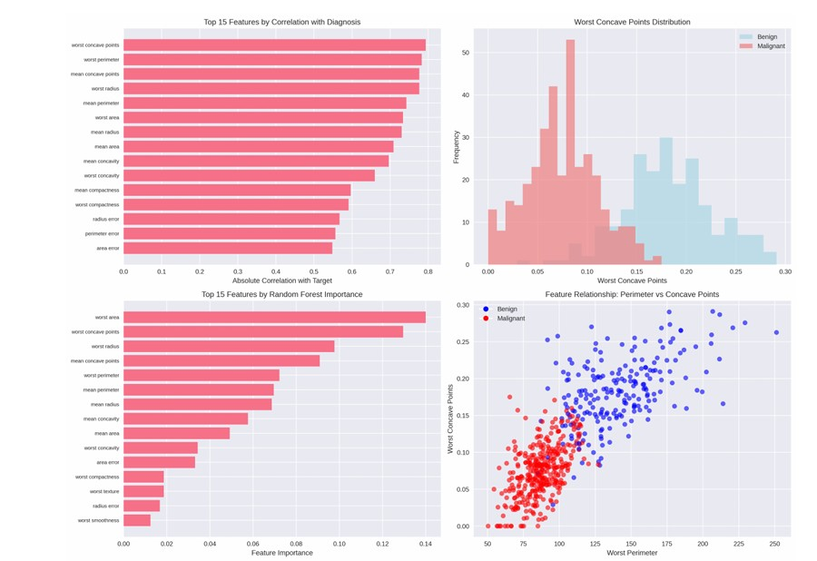

Figure 5: Data Exploration and Feature Analysis

**4.13**

**Project Presentation**

Thisprojectreport, alongwiththeaccompanyingcodeandvisualizations, serves

as the final deliverable for the project. The report provides a comprehensive

overview of the project, from the initial problem statement to the final results

and conclusion. The presentation will cover all the key aspects of the project,

including the methodology, results, and future work.

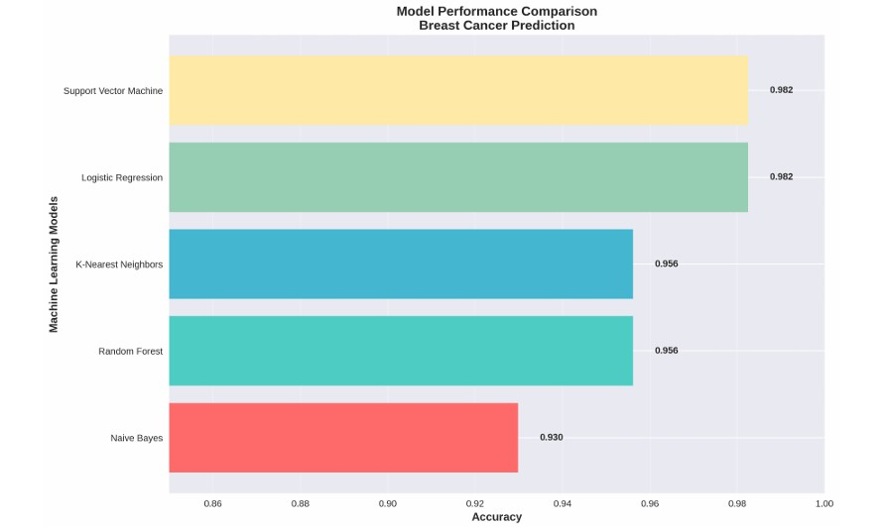

Figure 6: Model Performance and Evaluation

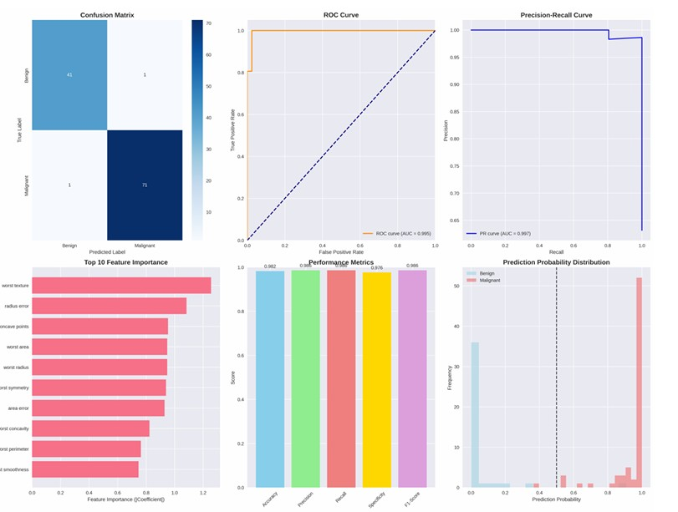

Figure 7: Model Performance and Evaluation

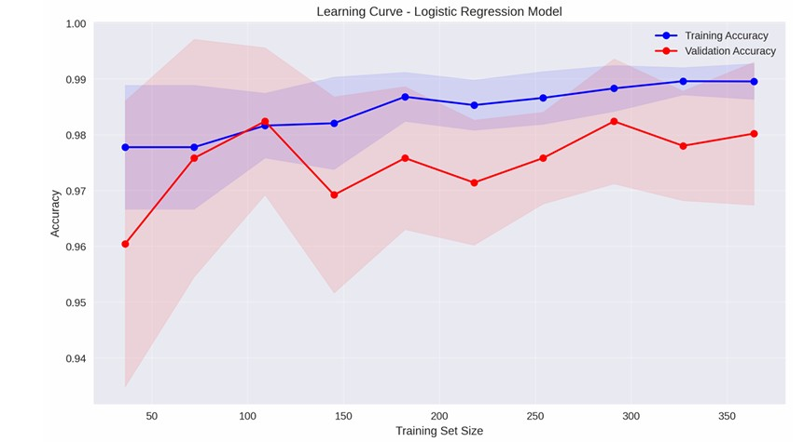

Figure 8: Model Performance and Evaluation

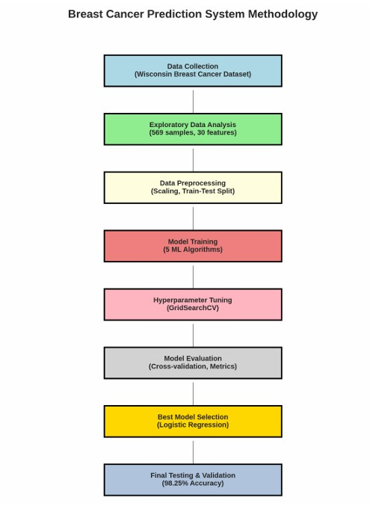

Figure 9: System Architecture and Methodology

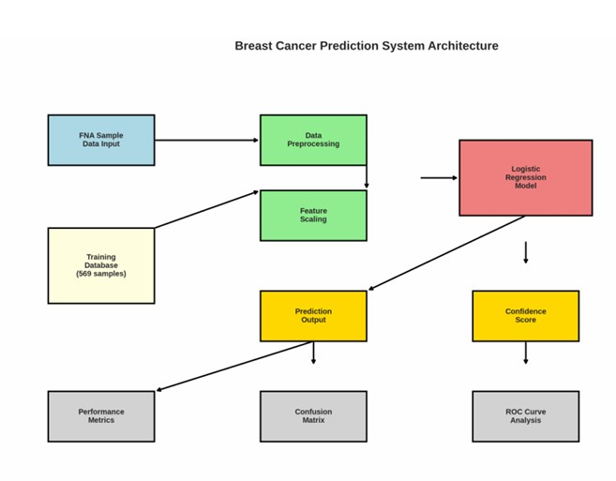

Figure 10: System Architecture and Methodology



**REFERENCES**

[1]

H. Tanveer, M. Faheem, A. H. Khan, and M. A. Adam, “Ai-powered diag-

nosis: A machine learning approach to early detection of breast cancer,”

*INTERNATIONAL JOURNAL OF ENGINEERING DEVELOPMENT AND*

*RESEARCH*

, vol. 13, no. 2, pp. 153–166, 2025.

[2]

P. RV and S. Sultana, “Comparative study of machine learning, deep learn-

ing and artificial intelligence algorithm used for the breast cancer progno-

sis.”

*Grenze International Journal of Engineering & Technology (GIJET)*

,

vol. 11, 2025.

[3]

A. Devarajan, “Artificial intelligence and machine learning in nano-based

breast cancer therapeutics,”

*Next-Gen Nanomedicine for Breast Cancer:*

*From Bench to Bedside and Beyond*

, p. 220, 2025.

[4]

M. G. Hanna, “Digital pathology and artificial intelligence in breast pathol-

ogy,”

*Surgical Pathology Clinics*

, 2025.

[5]

S. Vatta, “Role of artificial intelligence and machine learning in advancing

nanomedicineforbreastcancertherapy,”

*Next-GenNanomedicineforBreast*

*Cancer: From Bench to Bedside and Beyond*

, p. 274, 2025.

[6]

M. G. Hanna, L. Pantanowitz, B. Jackson, O. Palmer, S. Visweswaran,

J. Pantanowitz, M. Deebajah, and H. H. Rashidi, “Ethical and bias con-

siderations in artificial intelligence/machine learning,”

*Modern Pathology*

,

vol. 38, no. 3, p. 100686, 2025.

[7]

M. A. Rahman, M. S. H. Khan, Y. Watanobe, J. T. Prioty, T. T. Annita,

S. Rahman, M. S. Hossain, S. A. Aitijjo, R. I. Taskin, V. Dhrubo

*et al.*

, “Ad-

vancements in breast cancer detection: A review of global trends, risk fac-

tors, imaging modalities, machine learning, and deep learning approaches,”

*BioMedInformatics*

, vol. 5, no. 3, p. 46, 2025.